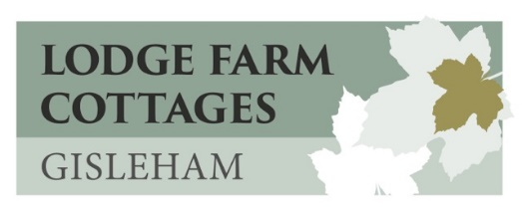
Privacy and Cookies Policy

Here at Lodge Farm Cottages we are committed to ensuring the best standards of practice in all of our activities. We take your privacy very seriously, and only use your personal information to provide the products and services you have requested from us. All personal information is collected, held and used in strict compliance with the General Data Protection Regulations which come into effect on 25th May 2018.
Our website www.lodgefarmcottages.co.uk uses a security system that protects your information from unauthorised use. No personal details are stored on this website. We will not sell, distribute or disclose information about you as an individual or your personal usage of the site without your consent or unless required or permitted to do so by law.
COOKIES
Information and data may be automatically collected through the use of cookies. Cookies are very small text files saved to your computer that are used to track user navigation around a website. They are not used to collect any personal information from you. They help us understand user numbers, speed up searches, recognise you when you return to the site and allow us to observe behaviour and compile aggregate data in order to improve the site for you. You may refuse to accept cookies by activating settings on your computer. If you refuse all cookies, you may not be able to access certain parts of our website.
We may monitor customer traffic patterns, site usage and related site information in order to optimise your use of the site and we may give aggregated statistics to a reputable third-party (Google Analytics), but these statistics will include no information personally identifying you.

WHAT INFORMATION DO WE COLLECT?
We receive your name, address, telephone numbers and email address when you book through our online booking system which is operated by Farmstay UK.
We receive your name, address, telephone numbers and email address when you complete our website contact form.
If you contact us by telephone, email or post, we may keep a record of this correspondence.
All information collected is used in relation to booking accommodation in our cottages. We retain all information from bookings and enquiries unless you ask us to delete it. We may contact you following your stay to ask you to submit a review of your visit. We may also use this information to contact you about future updates and events.

LINKS
We provide links on our website to other sites - Google maps, Facebook, local Visitor Attractions etc. These links may collect your IP address, which page you are visiting on our site and may set a cookie to enable the feature to work properly. Your use of these features are governed by the privacy policy of the company providing it.

We would like you to keep the information about you up-to-date. You may change any of the basic information we keep about you by sending us an e-mail to bridget@lodgefarmcottages.co.uk. In addition to the information which you supply to us we continually strive to improve our standards of customer care at Lodge Farm Cottages, so your feedback is most welcome.
If you have any further queries, please do not hesitate to contact us on the information below.
Lodge Farm Cottages
Gisleham
Lowestoft
Suffolk
NR33 8DT
bridget@lodgefarmcottages.co.uk
We control and operate this website from our offices within England. Accordingly the laws of England and Wales govern claims relating to, including the use of, this website any material contained therein. If you choose to access our web site from outside England and Wales you do so on your own initiative and you solely agree that in the event of a dispute between ourselves and you, the laws of England and Wales will apply at all times.

Updated May 2018

