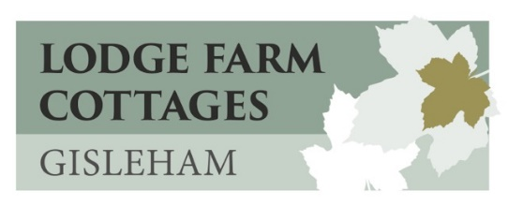
COVID-19 Information
We take the health and safety of our guests very seriously particularly in these difficult times. Lodge Farm Cottages have achieved the Visit England "We're Good to Go" Mark and The AA “Covid-19 Confident” Award which means we are following Government and industry COVID-19 guidelines and have all the correct cleaning protocols and preparations in place for making your stay as safe as we can.
If you feel ill before your stay you MUST cancel your booking. We are offering to move or refund your booking if you are unable to stay due to Covid lockdown measures. (See our Terms & Conditions)
We have carried out Covid cleaning training and completed risk assessments so that we are able to assure our guests that we can welcome you safely to our cottages.
Please take note that we have adjusted our arrival time to 5pm and departure time to 9.30am in order to give us plenty of time to complete our enhanced cleaning routine.
As well as our usual thorough clean, the cottages are also cleaned using virucidal disinfectants that are certified to kill Corona Virus 19. We have provided hand sanitisers and additional cleaning materials for your own use during your stay.
We may still welcome you on arrival as always, but we will be maintaining social distancing. The cottage door is unlocked ready for you, your keys will have been disinfected and left on the table.
We supply all towels and bedding but you are welcome to bring your own if you wish, just let us know.
There are a reduced amount of books, board games & toys, cushions & throws, and tourist information in each cottage and we are rotating these after each booking. We apologise that the cottage might look a bit barer than usual and doesn’t quite have its usual home from home feel!
On departure day we ask you to help with our safety measures by emptying all bins and opening all windows before you leave. We also ask you to strip your own beds and place all linen and towels in the bags provided.
We want you to enjoy your break with us, and we are doing all we can to make your stay as safe as possible. We look forward to welcoming you all soon.
